PES UNIVERSITY, Bangalore
Established under Karnataka Act No. 16 of 2013)
Department of Computer Science & Engineering
UE24CS251A: DIGITAL DESIGN AND COMPUTER ORGANIZATION

Automated RAM

Name: Vivian Sobers E
SRN: PES1UG24CS901

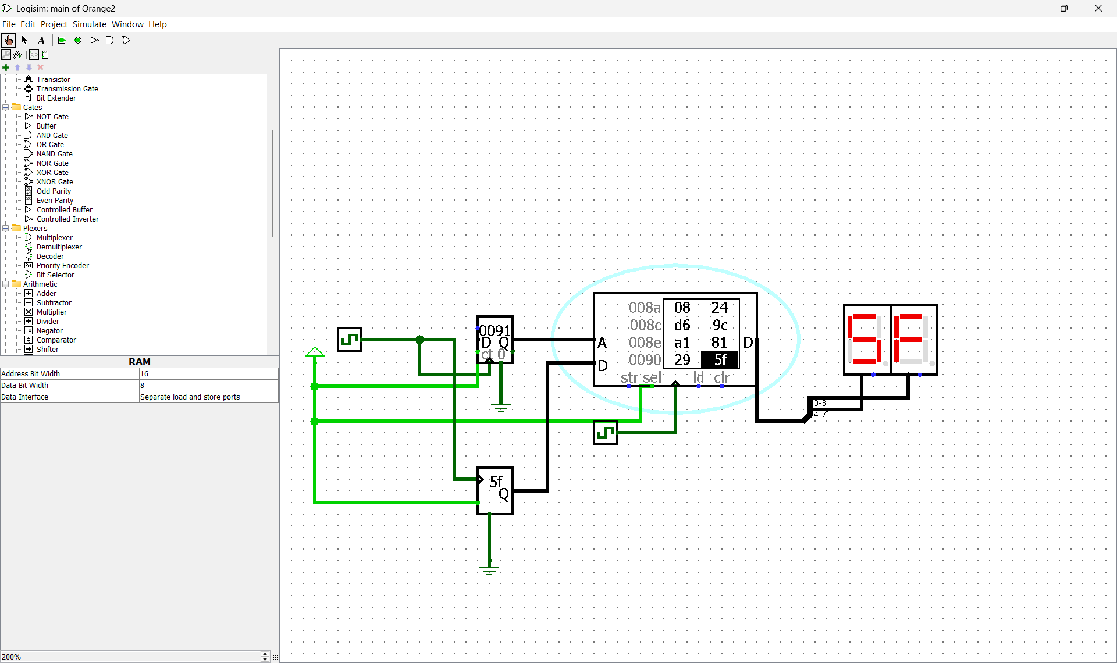
- When you start the simulation, which RAM addresses are written first?
The lowest address (0000h) is written first.
- The counter starts counting from 0 after reset.
- So, the RAM’s address input (A) begins at 0000, and that’s the first memory cell where data from the random generator is stored.
- Then it proceeds sequentially: 0001, 0002, 0003, … and so on.

- How many bits wide is the RAM data word and why did you set the Random Generator to that width?
The RAM data width is 8 bits, so the random generator is also configured to 8 bits.
- This ensures every random value exactly matches one RAM data word.
- If the widths didn’t match, Logisim would show “bit width mismatch” or the stored values would be truncated or padded with zeros.

- What happens if you tie the RAM st (store enable) pin to Ground instead of 1?
If st is connected to Ground (0):
- The RAM will not perform any write operations.
- The random data will still be generated, and addresses will still change,
but no new data will be written into memory.
- You’ll just see the same old stored values in the RAM viewer (it effectively goes into read-only mode).

- Experiment: change Clock A to run at the same speed as Clock B. What happens to the stored values?
When both clocks tick at the same rate, the random generator updates at the same instant the RAM writes data.
- This causes the random value to not stabilize before the RAM write pulse,
so the same value may get written into several consecutive addresses.
- Result: many memory locations will show repeated or similar values, reducing randomness.

- Why is the frequency of Clock A ticks set to be twice the rate (2 ticks per RAM cycle) of Clock B?
Clock A runs faster to ensure:
- The random generator updates to a new random number before each RAM write event.
- So for every one RAM write (Clock B pulse), the random generator produces two stable random updates, guaranteeing that when Clock B triggers, a valid and stable random byte is available to write.
- This ensures each RAM location gets a unique random value.

